**Collaboration Diagram**

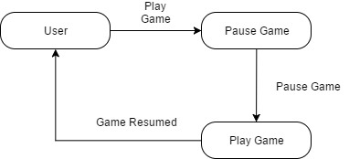

***Figure 1: Continue Game***

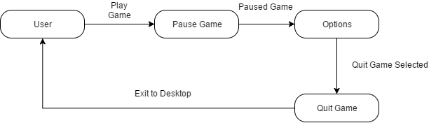

***Figure 2: Exit Game***

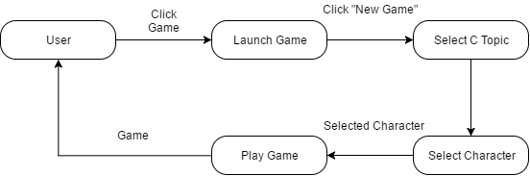

***Figure 3: New Game***

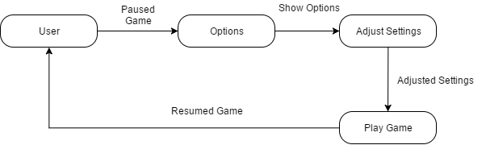

***Figure 4: Options***

Pause Game Collaboration Diagram

***Figure 5: Pause Game***

**Statechart Diagram**

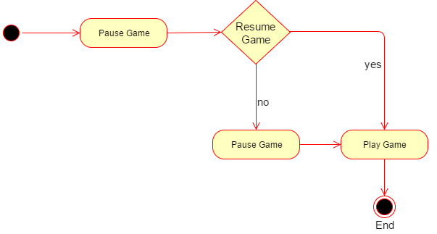

***Figure 6: Continue Game***

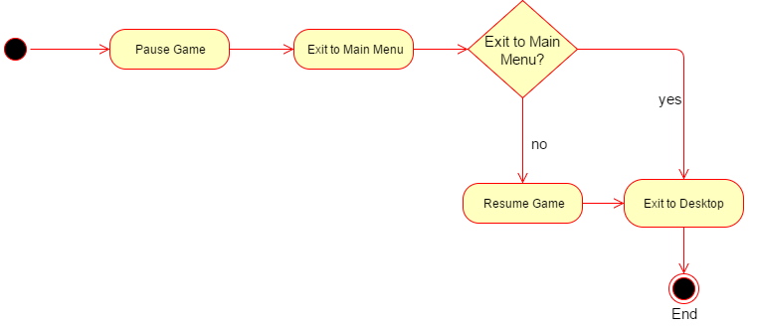

***Figure 7: Exit Game***

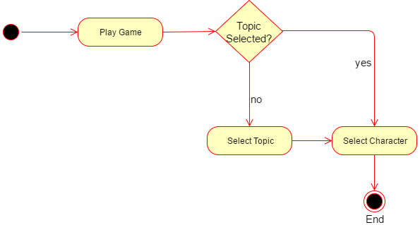

***Figure 8: New Game***

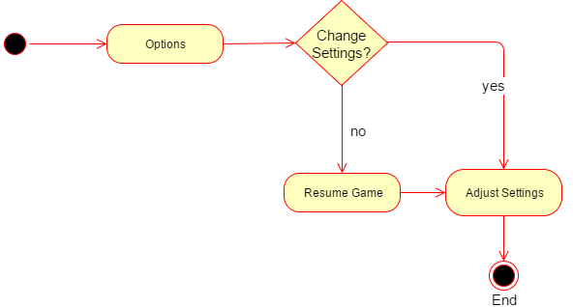

***Figure 9: Options***

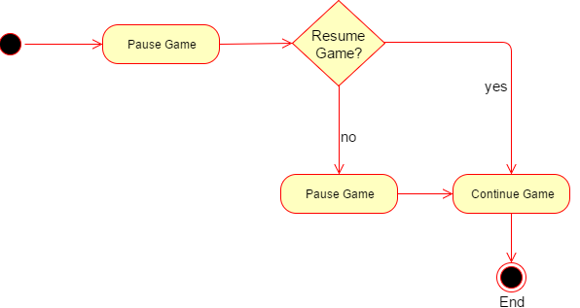

***Figure 10: Pause Game***

**Class Diagram**

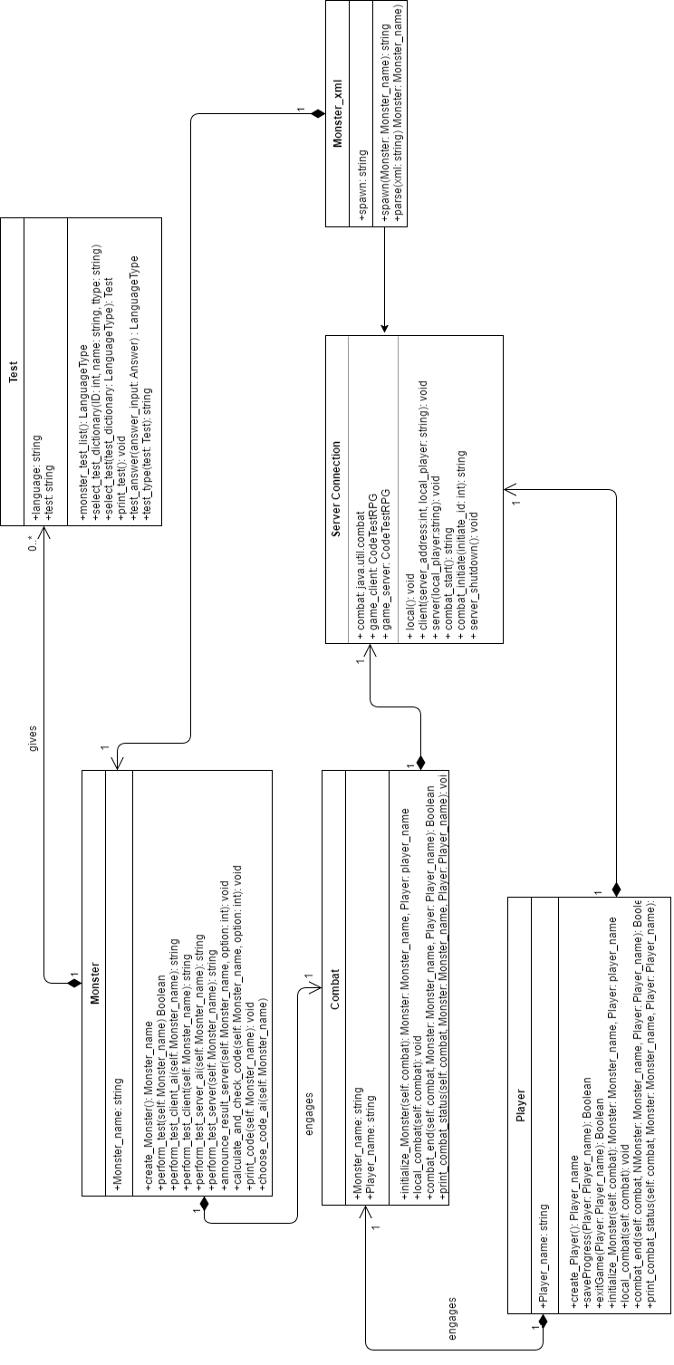

***Figure 11: Class Diagram***

**Sequence Diagrams**

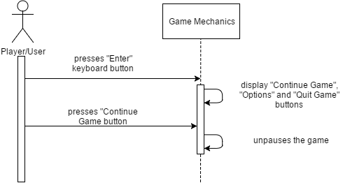

***Figure 12: Continue Game Sequence Diagram***

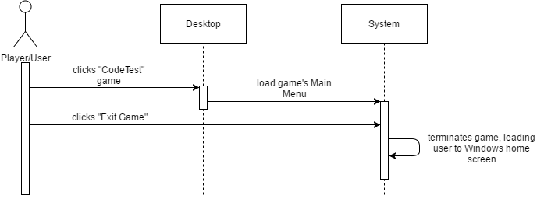

***Figure 13: Exit Game Sequence Diagram***

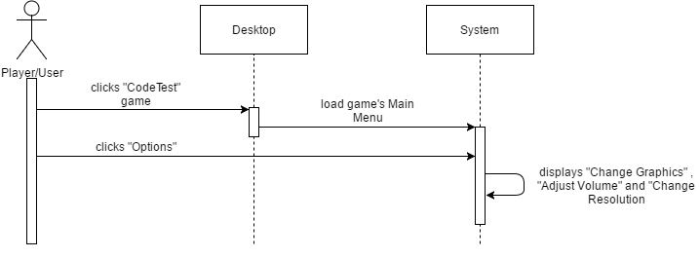

***Figure 14: Options Sequence Diagram***

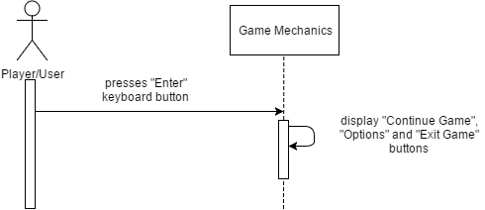

***Figure 15: Pause Game Sequence Diagram***

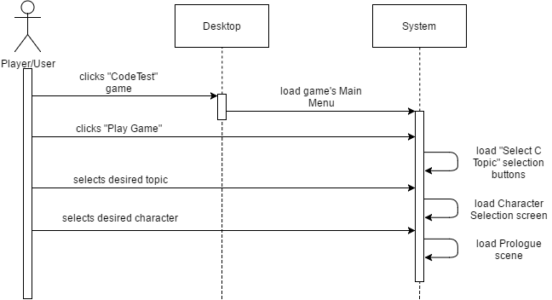

***Figure 16: Play Game Sequence Diagram***

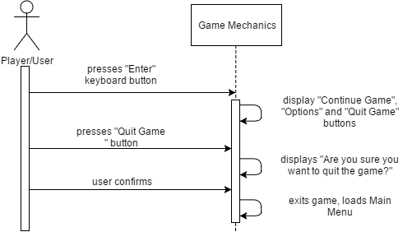

***Figure 17: Quit Game Sequence Diagram***

**Activity Diagrams**

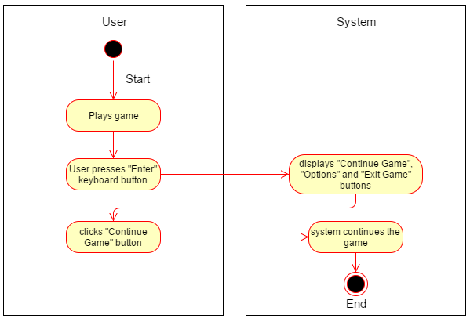

***Figure 18: Continue Game Activity Diagram***

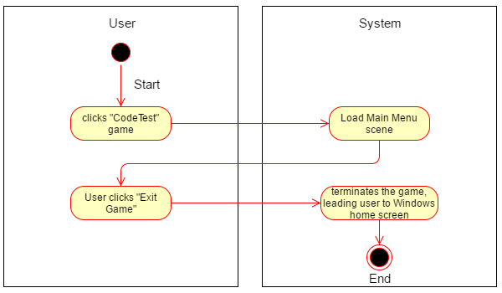

***Figure 19: Exit Game Activity Diagram***

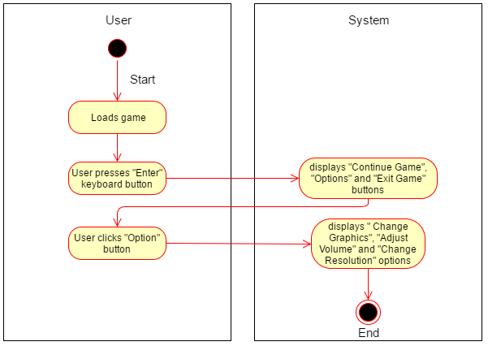

***Figure 20: Options Activity Diagram***

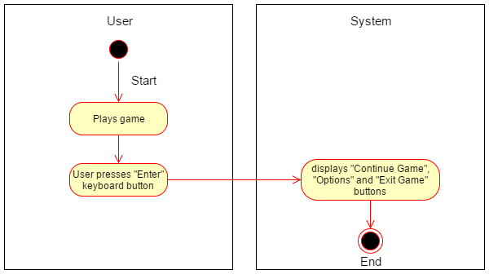

***Figure 21: Pause Game Activity Diagram***

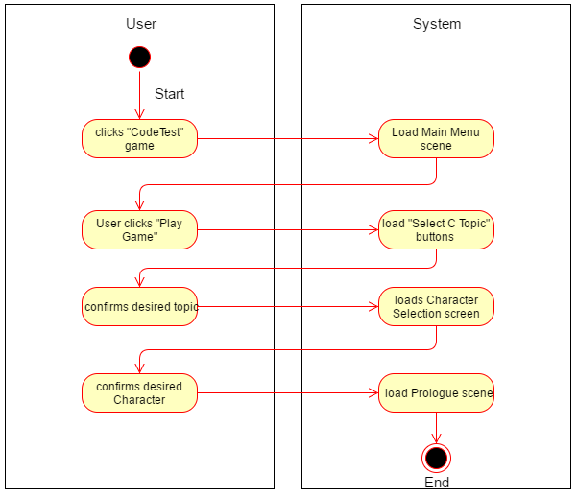

***Figure 22: Play Game Activity Diagram***

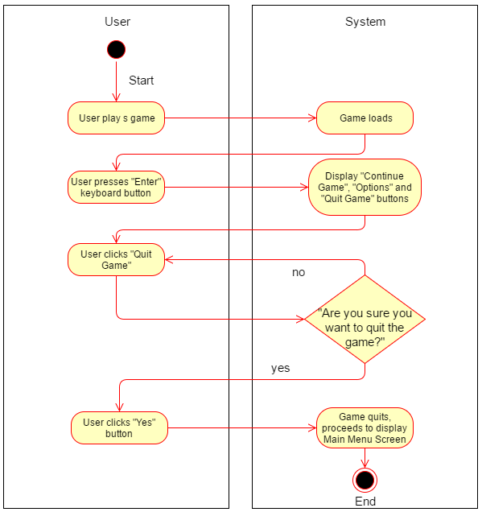

***Figure 23: Quit Game Activity Diagram***

**Communication Diagram**

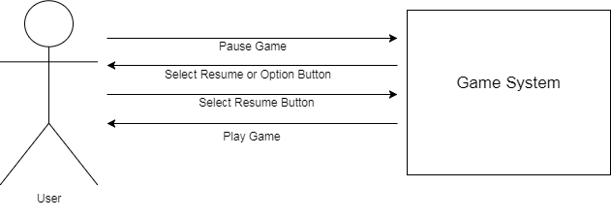

***Figure 24: Continue Game***

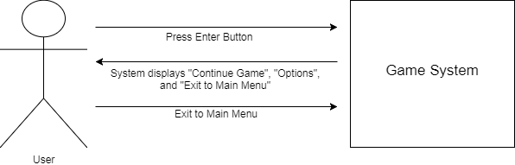

***Figure 25: Exit Game***

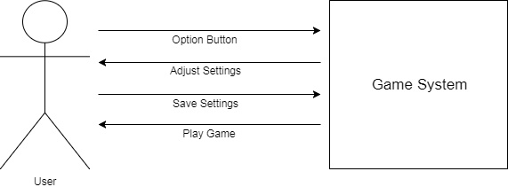

***Figure 26: Options***

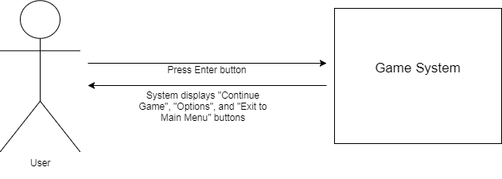

***Figure 27: Pause Game***

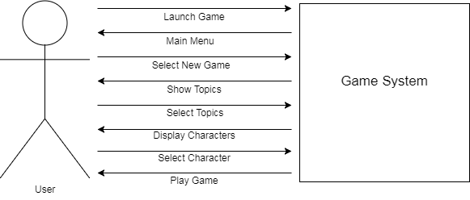

***Figure 28: Play Game***

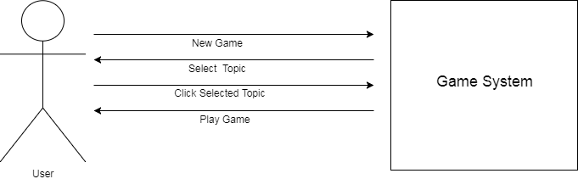

***Figure 30: New Game***